Computer Architecture and Organization
Digital Assignment 3
Name: Harshit Kakati
Reg No. 24BCE1450
Prof Dr. Abdul Quadir
Slot: E2+TE2
Aim: To execute Project 3 and Project 4
Project 3:
- Single Bit ram:
Code:
CHIP Bit {
IN in, load;
OUT out;

PARTS:
Mux(a=dffOut, b=in, sel=load, out=muxOut);
DFF(in=muxOut, out=dffOut);
Or(a=false, b=dffOut, out=out);
}
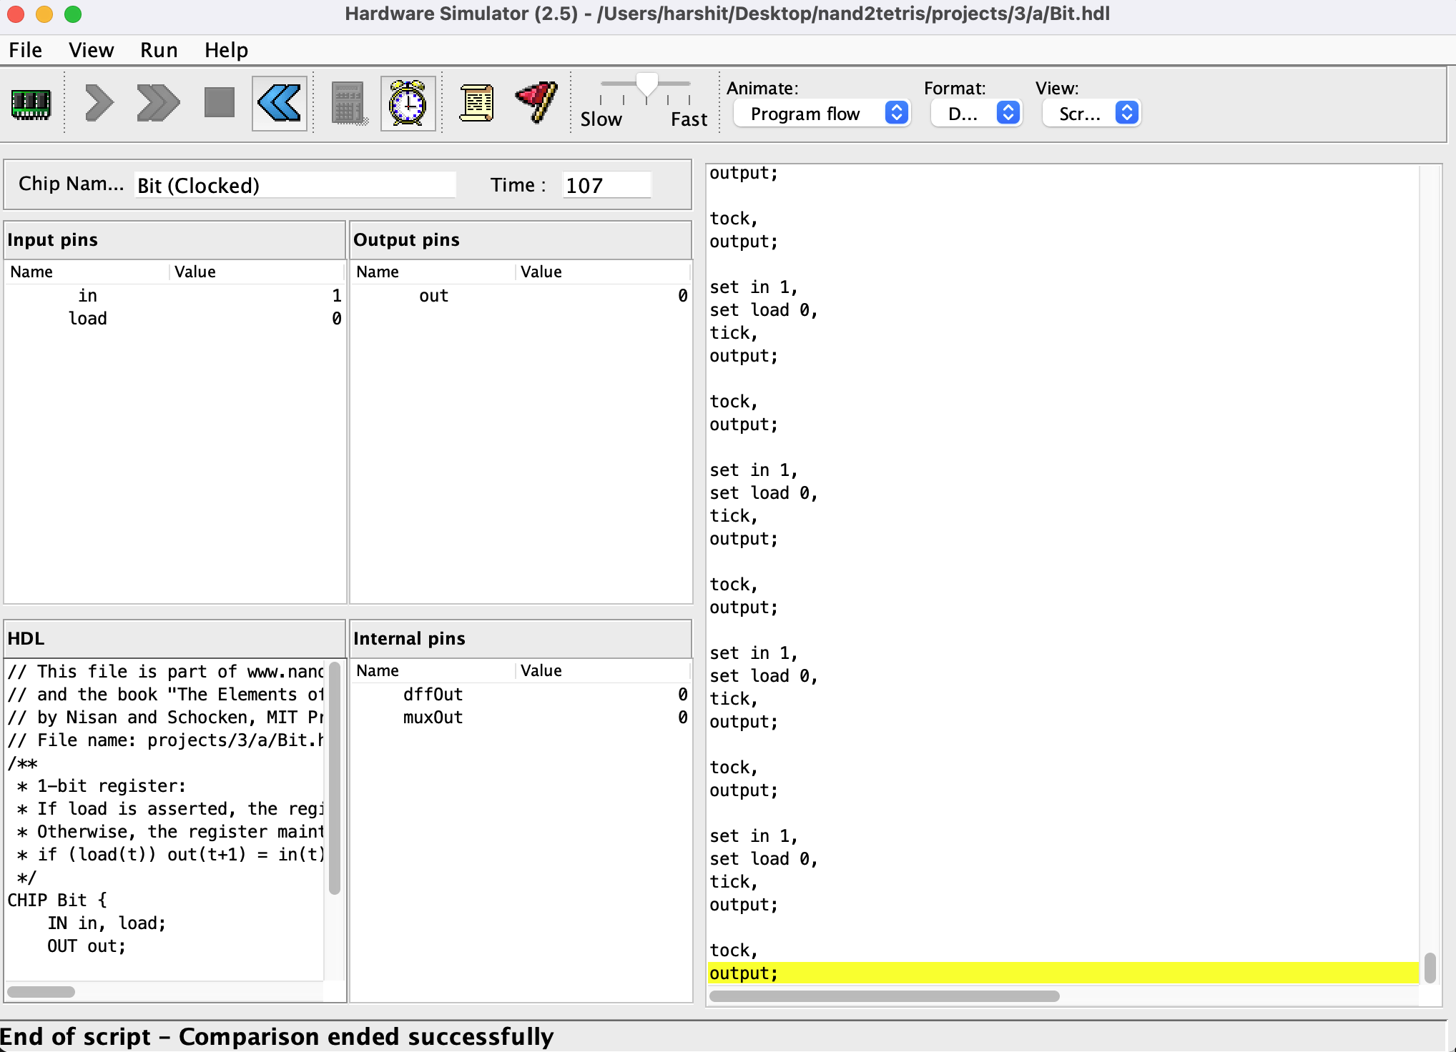
- Register 16 bit:
CHIP Register {
IN in[16], load;
OUT out[16];

PARTS:
Bit(in=in[0], load=load, out=out[0]);
Bit(in=in[1], load=load, out=out[1]);
Bit(in=in[2], load=load, out=out[2]);
Bit(in=in[3], load=load, out=out[3]);
Bit(in=in[4], load=load, out=out[4]);
Bit(in=in[5], load=load, out=out[5]);
Bit(in=in[6], load=load, out=out[6]);
Bit(in=in[7], load=load, out=out[7]);
Bit(in=in[8], load=load, out=out[8]);
Bit(in=in[9], load=load, out=out[9]);
Bit(in=in[10], load=load, out=out[10]);
Bit(in=in[11], load=load, out=out[11]);
Bit(in=in[12], load=load, out=out[12]);
Bit(in=in[13], load=load, out=out[13]);
Bit(in=in[14], load=load, out=out[14]);
Bit(in=in[15], load=load, out=out[15]);
}

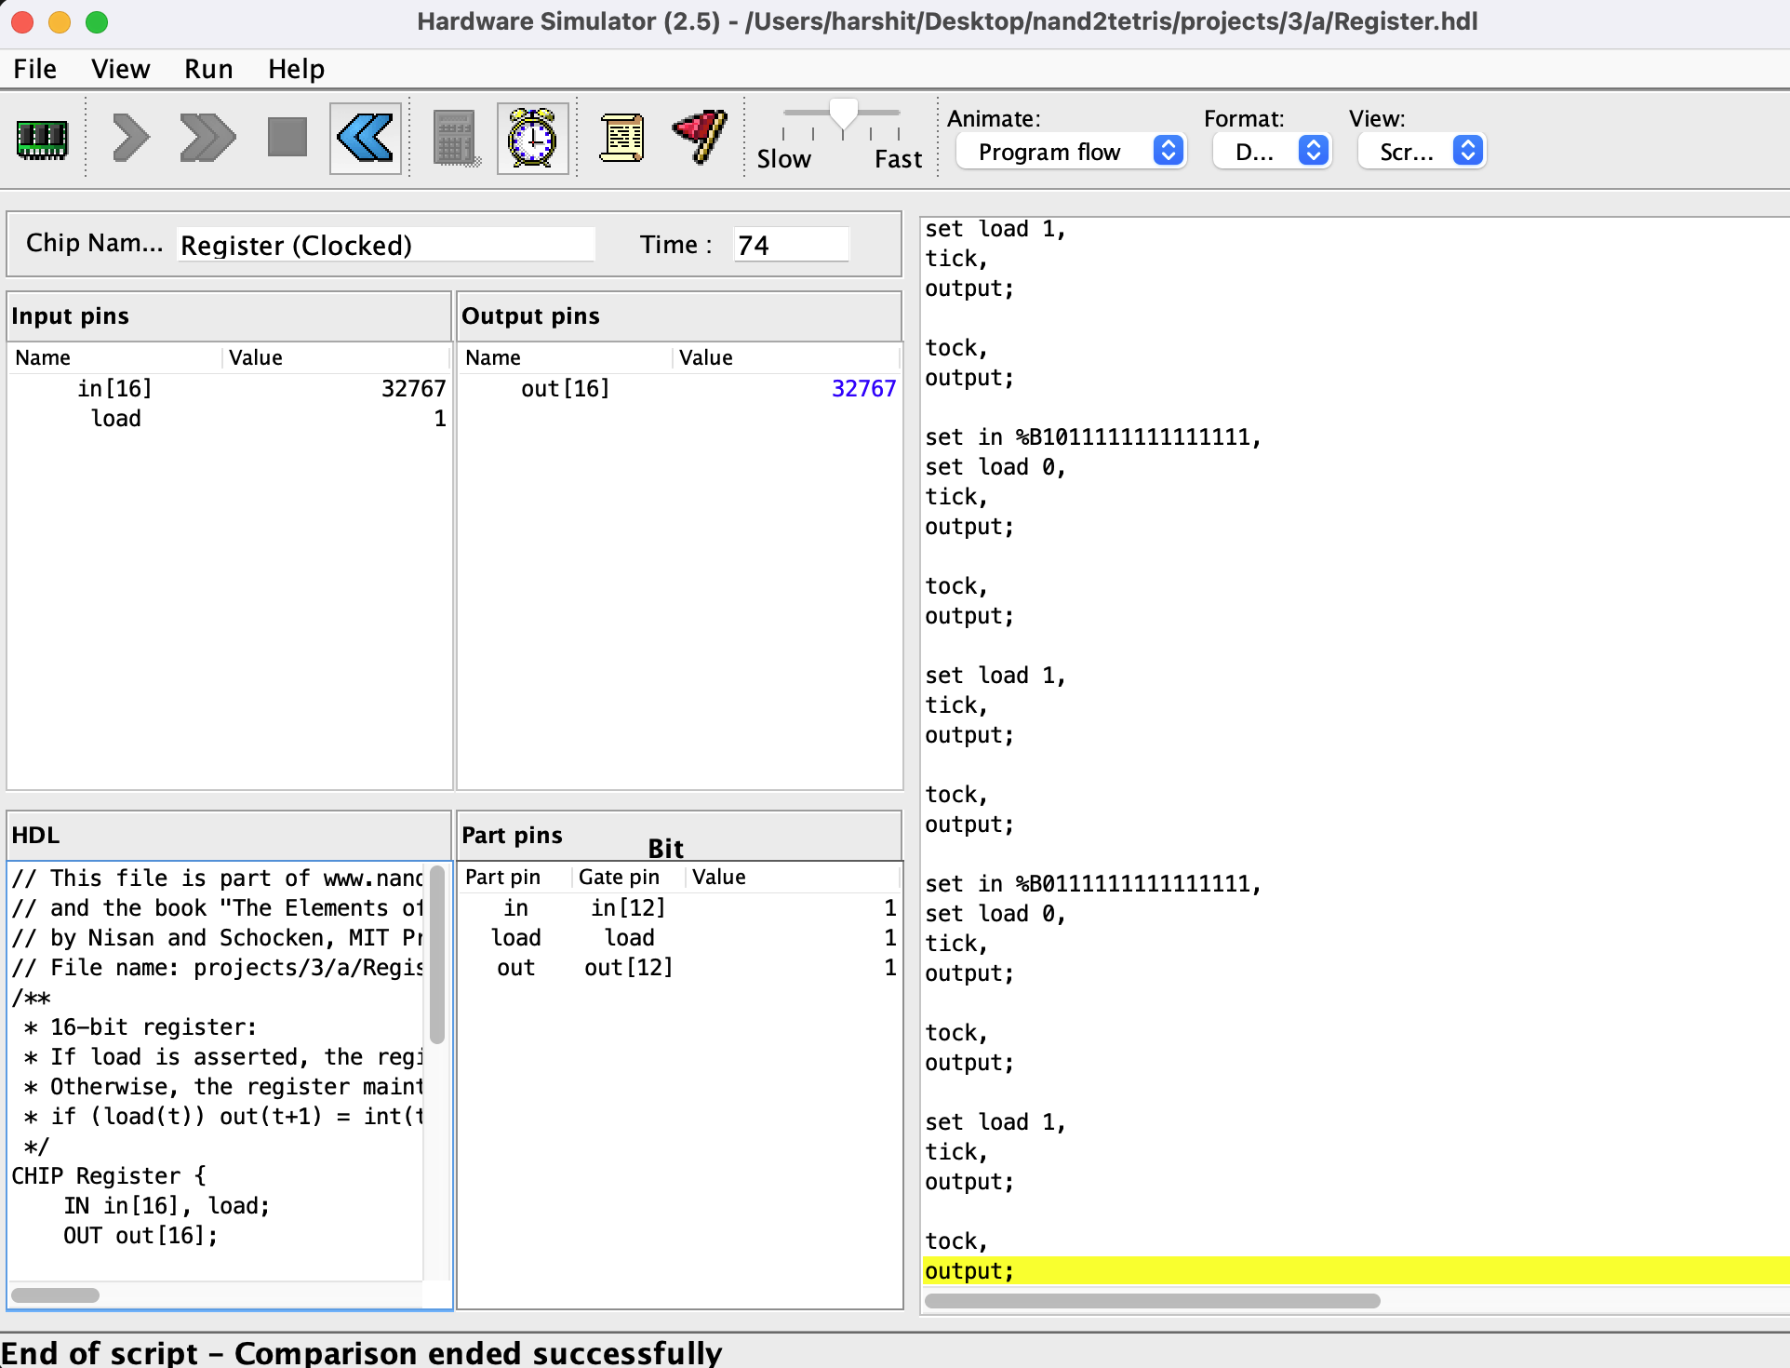
- Ram 8 Bit:
CHIP RAM8 {
IN in[16], load, address[3];
OUT out[16];

PARTS:
DMux8Way(in=load, sel=address,
a=sel0,
b=sel1,
c=sel2,
d=sel3,
e=sel4,
f=sel5,
g=sel6,
h=sel7
);

Register(in=in, load=sel0, out=r0);
Register(in=in, load=sel1, out=r1);
Register(in=in, load=sel2, out=r2);
Register(in=in, load=sel3, out=r3);
Register(in=in, load=sel4, out=r4);
Register(in=in, load=sel5, out=r5);
Register(in=in, load=sel6, out=r6);
Register(in=in, load=sel7, out=r7);

Mux8Way16(
a=r0,
b=r1,
c=r2,
d=r3,
e=r4,
f=r5,
g=r6,
h=r7,
sel=address,
out=out);
}
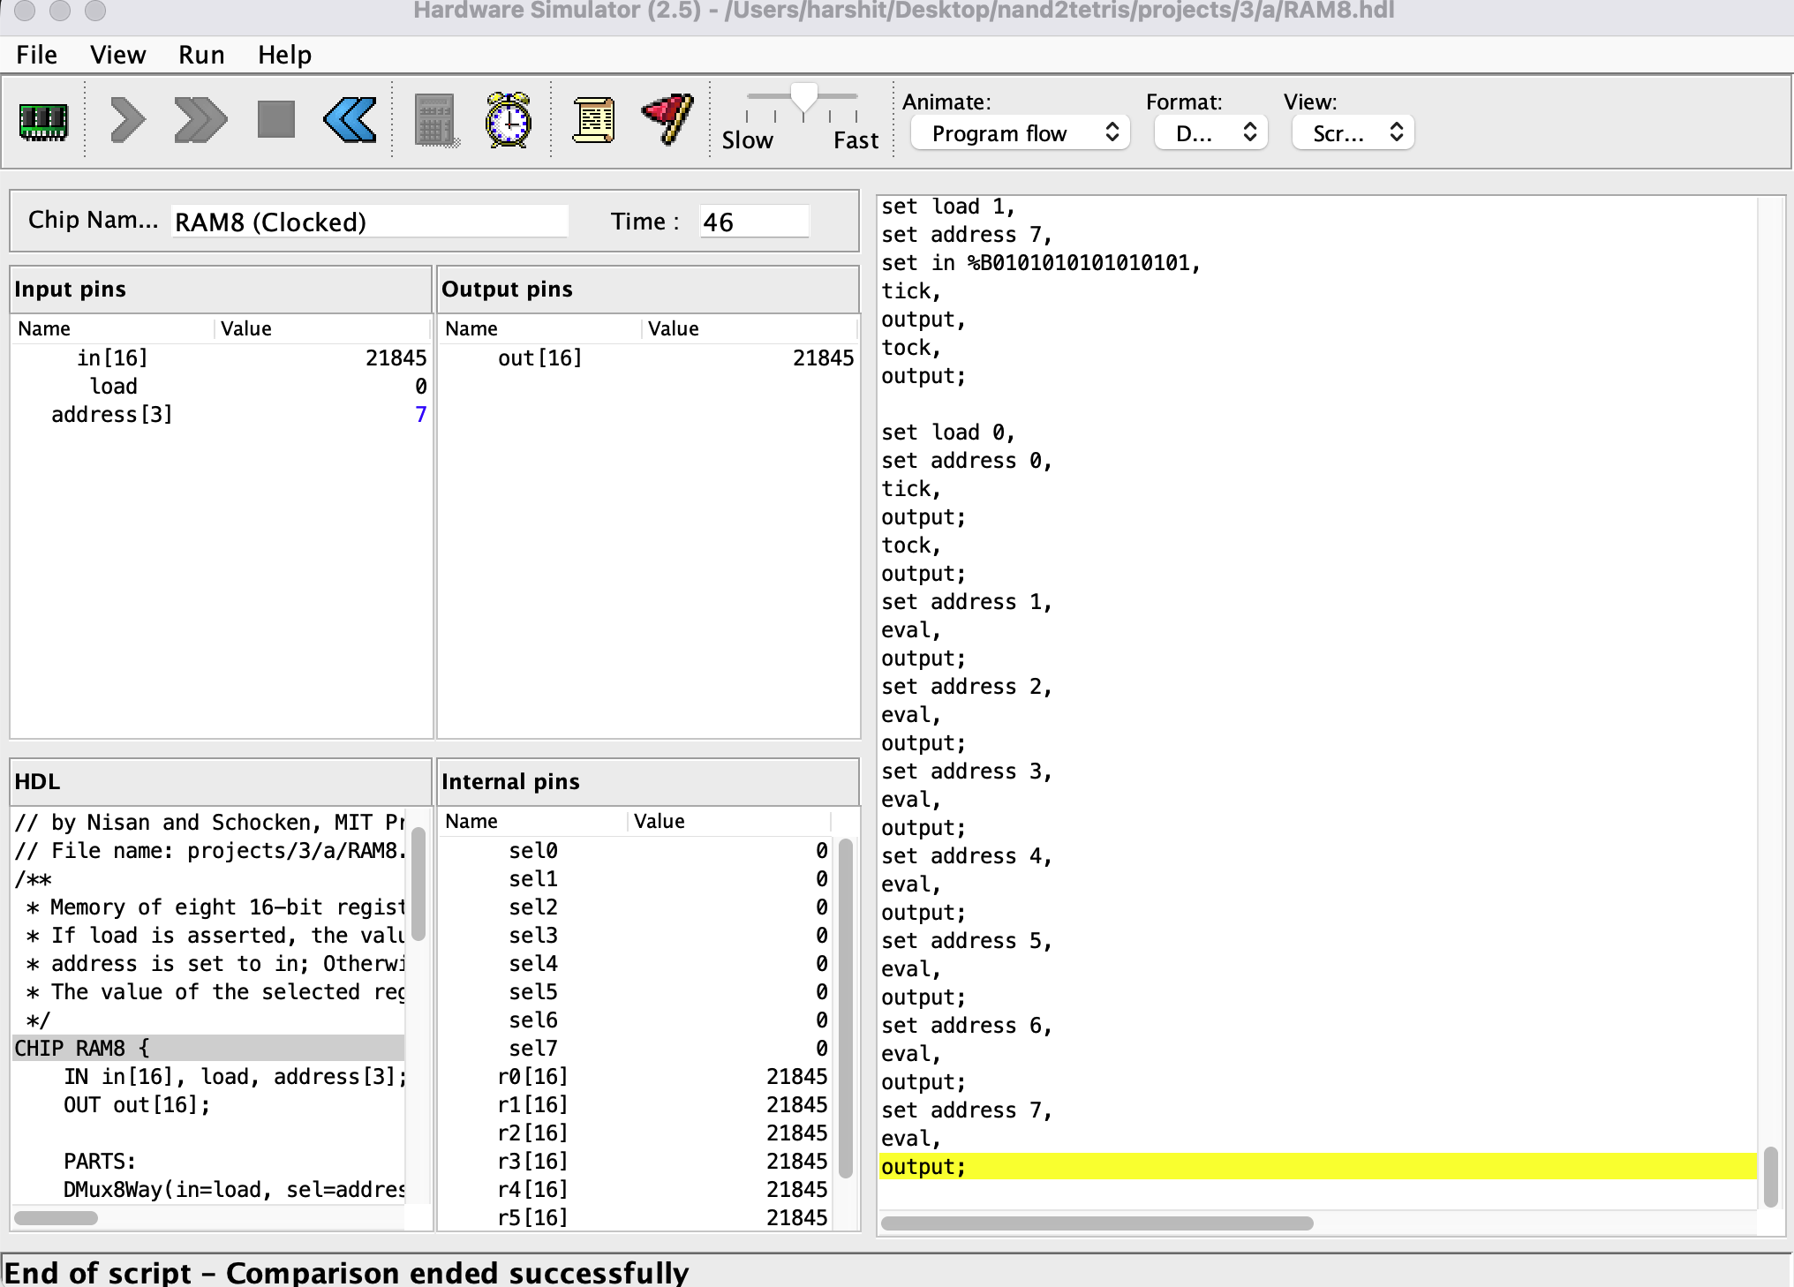

- Ram 64 Bit:
CHIP RAM64 {
IN in[16], load, address[6];
OUT out[16];

PARTS:
DMux8Way(in=load, sel=address[3..5],
a=sel0,
b=sel1,
c=sel2,
d=sel3,
e=sel4,
f=sel5,
g=sel6,
h=sel7
);

RAM8(in=in, load=sel0, address=address[0..2], out=r0);
RAM8(in=in, load=sel1, address=address[0..2], out=r1);
RAM8(in=in, load=sel2, address=address[0..2], out=r2);
RAM8(in=in, load=sel3, address=address[0..2], out=r3);
RAM8(in=in, load=sel4, address=address[0..2], out=r4);
RAM8(in=in, load=sel5, address=address[0..2], out=r5);
RAM8(in=in, load=sel6, address=address[0..2], out=r6);
RAM8(in=in, load=sel7, address=address[0..2], out=r7);

Mux8Way16(
a=r0,
b=r1,
c=r2,
d=r3,
e=r4,
f=r5,
g=r6,
h=r7,
sel=address[3..5],
out=out);
}
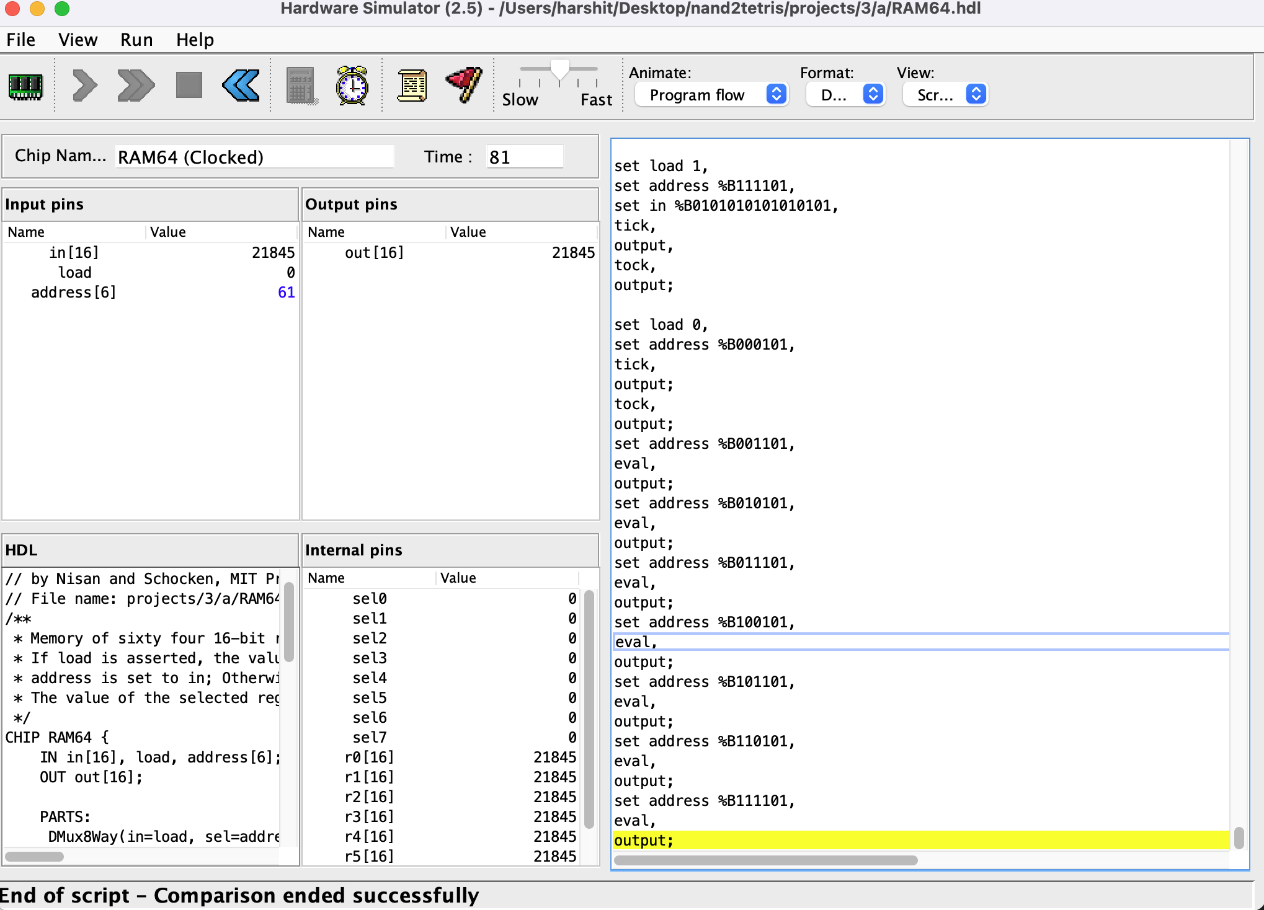
- PC(Program Counter):
CHIP PC {
IN in[16],inc, load, reset;
OUT out[16];

PARTS:
Inc16(in=regOutput, out=regOutputInc);
Mux16(a=regOutput, b=regOutputInc, sel=inc, out=out1);
Mux16(a=out1, b=in, sel=load, out=out2);
Mux16(a=out2, b=false, sel=reset, out=regInput);

Or(a=load, b=inc, out=loadOrInc);
Or(a=loadOrInc, b=reset, out=loadOrIncOrReset);

Register(in=regInput, load=loadOrIncOrReset, out=regOutput);

Or16(a=false, b=regOutput, out=out);
}
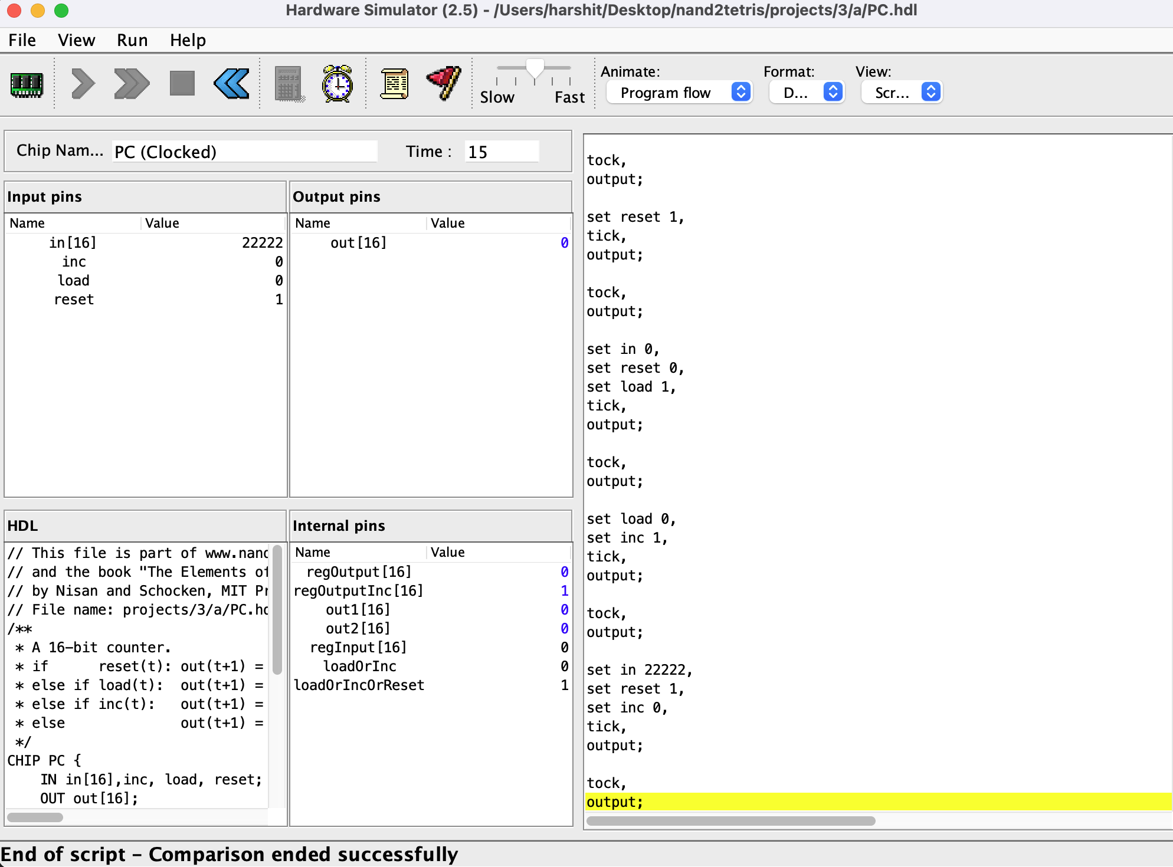
- RAM 4K:
CHIP RAM4K {
IN in[16], load, address[12];
OUT out[16];

PARTS:
DMux8Way(in=load, sel=address[9..11],
a=sel0,
b=sel1,
c=sel2,
d=sel3,
e=sel4,
f=sel5,
g=sel6,
h=sel7
);

RAM512(in=in, load=sel0, address=address[0..8], out=r0);
RAM512(in=in, load=sel1, address=address[0..8], out=r1);
RAM512(in=in, load=sel2, address=address[0..8], out=r2);
RAM512(in=in, load=sel3, address=address[0..8], out=r3);
RAM512(in=in, load=sel4, address=address[0..8], out=r4);
RAM512(in=in, load=sel5, address=address[0..8], out=r5);
RAM512(in=in, load=sel6, address=address[0..8], out=r6);
RAM512(in=in, load=sel7, address=address[0..8], out=r7);

Mux8Way16(
a=r0,
b=r1,
c=r2,
d=r3,
e=r4,
f=r5,
g=r6,
h=r7,
sel=address[9..11],
out=out);
}
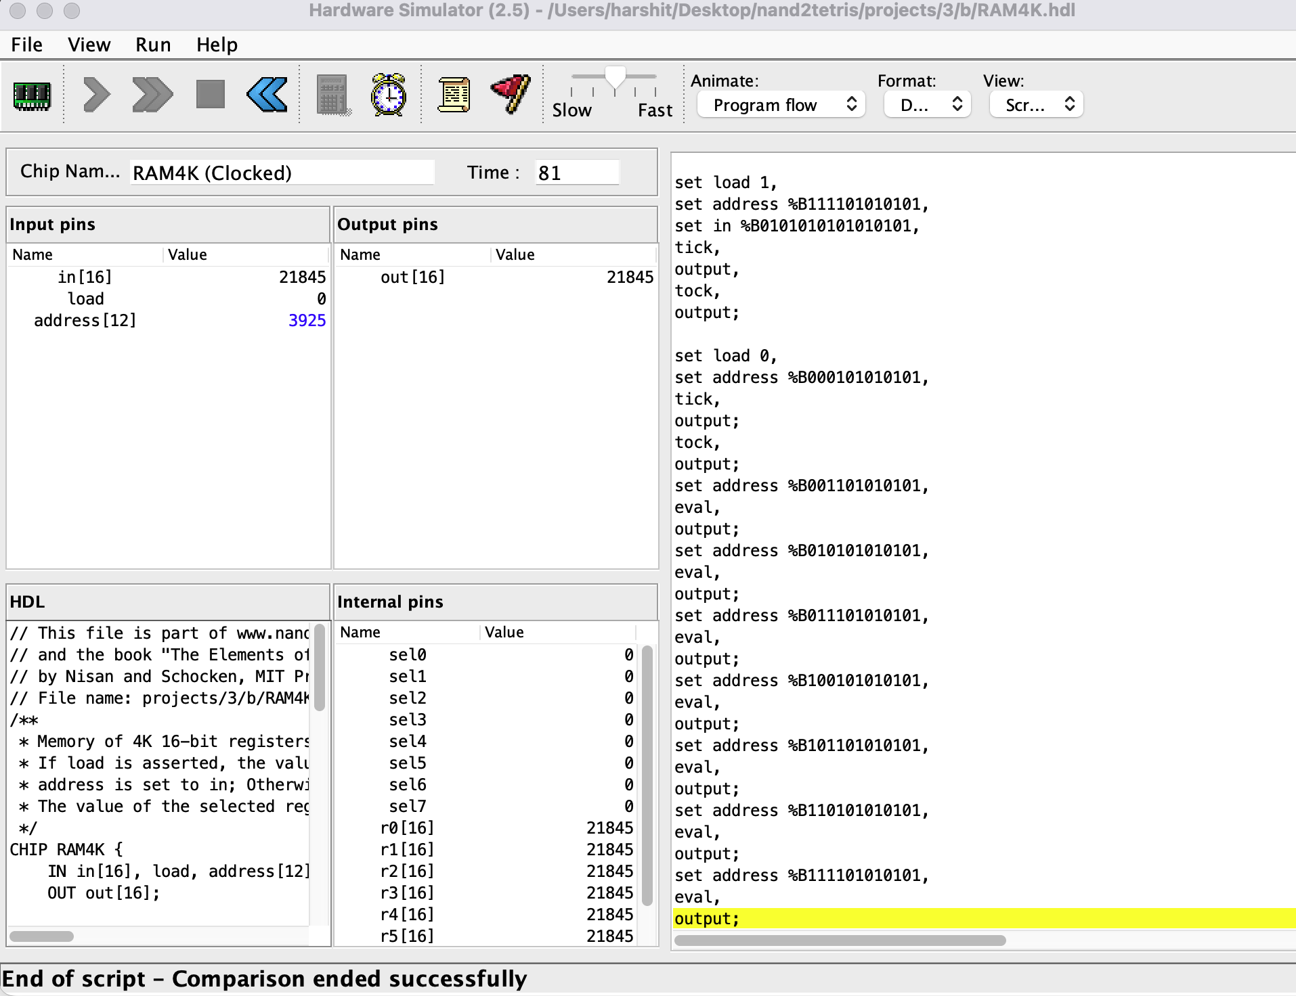
- RAM 512 Bit:
CHIP RAM512 {
IN in[16], load, address[9];
OUT out[16];

PARTS:
DMux8Way(in=load, sel=address[6..8],
a=sel0,
b=sel1,
c=sel2,
d=sel3,
e=sel4,
f=sel5,
g=sel6,
h=sel7
);

RAM64(in=in, load=sel0, address=address[0..5], out=r0);
RAM64(in=in, load=sel1, address=address[0..5], out=r1);
RAM64(in=in, load=sel2, address=address[0..5], out=r2);
RAM64(in=in, load=sel3, address=address[0..5], out=r3);
RAM64(in=in, load=sel4, address=address[0..5], out=r4);
RAM64(in=in, load=sel5, address=address[0..5], out=r5);
RAM64(in=in, load=sel6, address=address[0..5], out=r6);
RAM64(in=in, load=sel7, address=address[0..5], out=r7);

Mux8Way16(
a=r0,
b=r1,
c=r2,
d=r3,
e=r4,
f=r5,
g=r6,
h=r7,
sel=address[6..8],
out=out);
}
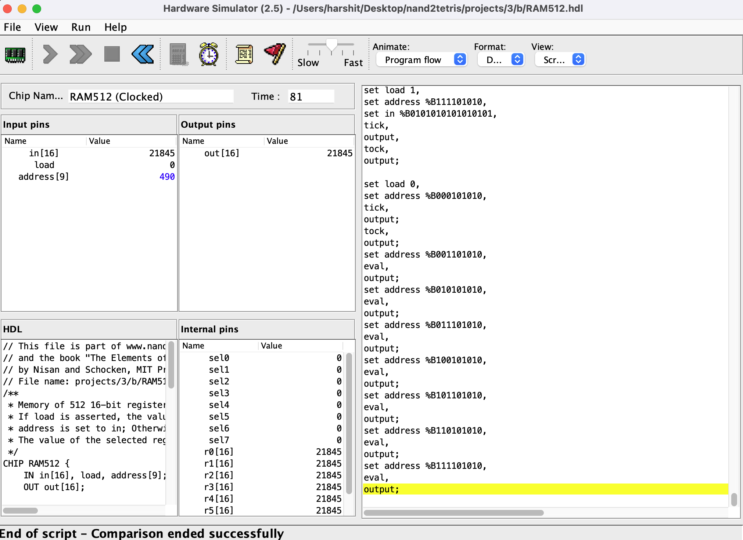
- RAM 16K:
CHIP RAM16K {
IN in[16], load, address[14];
OUT out[16];

PARTS:
DMux4Way(in=load, sel=address[12..13],
a=sel0,
b=sel1,
c=sel2,
d=sel3
);

RAM4K(in=in, load=sel0, address=address[0..11], out=r0);
RAM4K(in=in, load=sel1, address=address[0..11], out=r1);
RAM4K(in=in, load=sel2, address=address[0..11], out=r2);
RAM4K(in=in, load=sel3, address=address[0..11], out=r3);

Mux4Way16(
a=r0,
b=r1,
c=r2,
d=r3,
sel=address[12..13],
out=out);
}

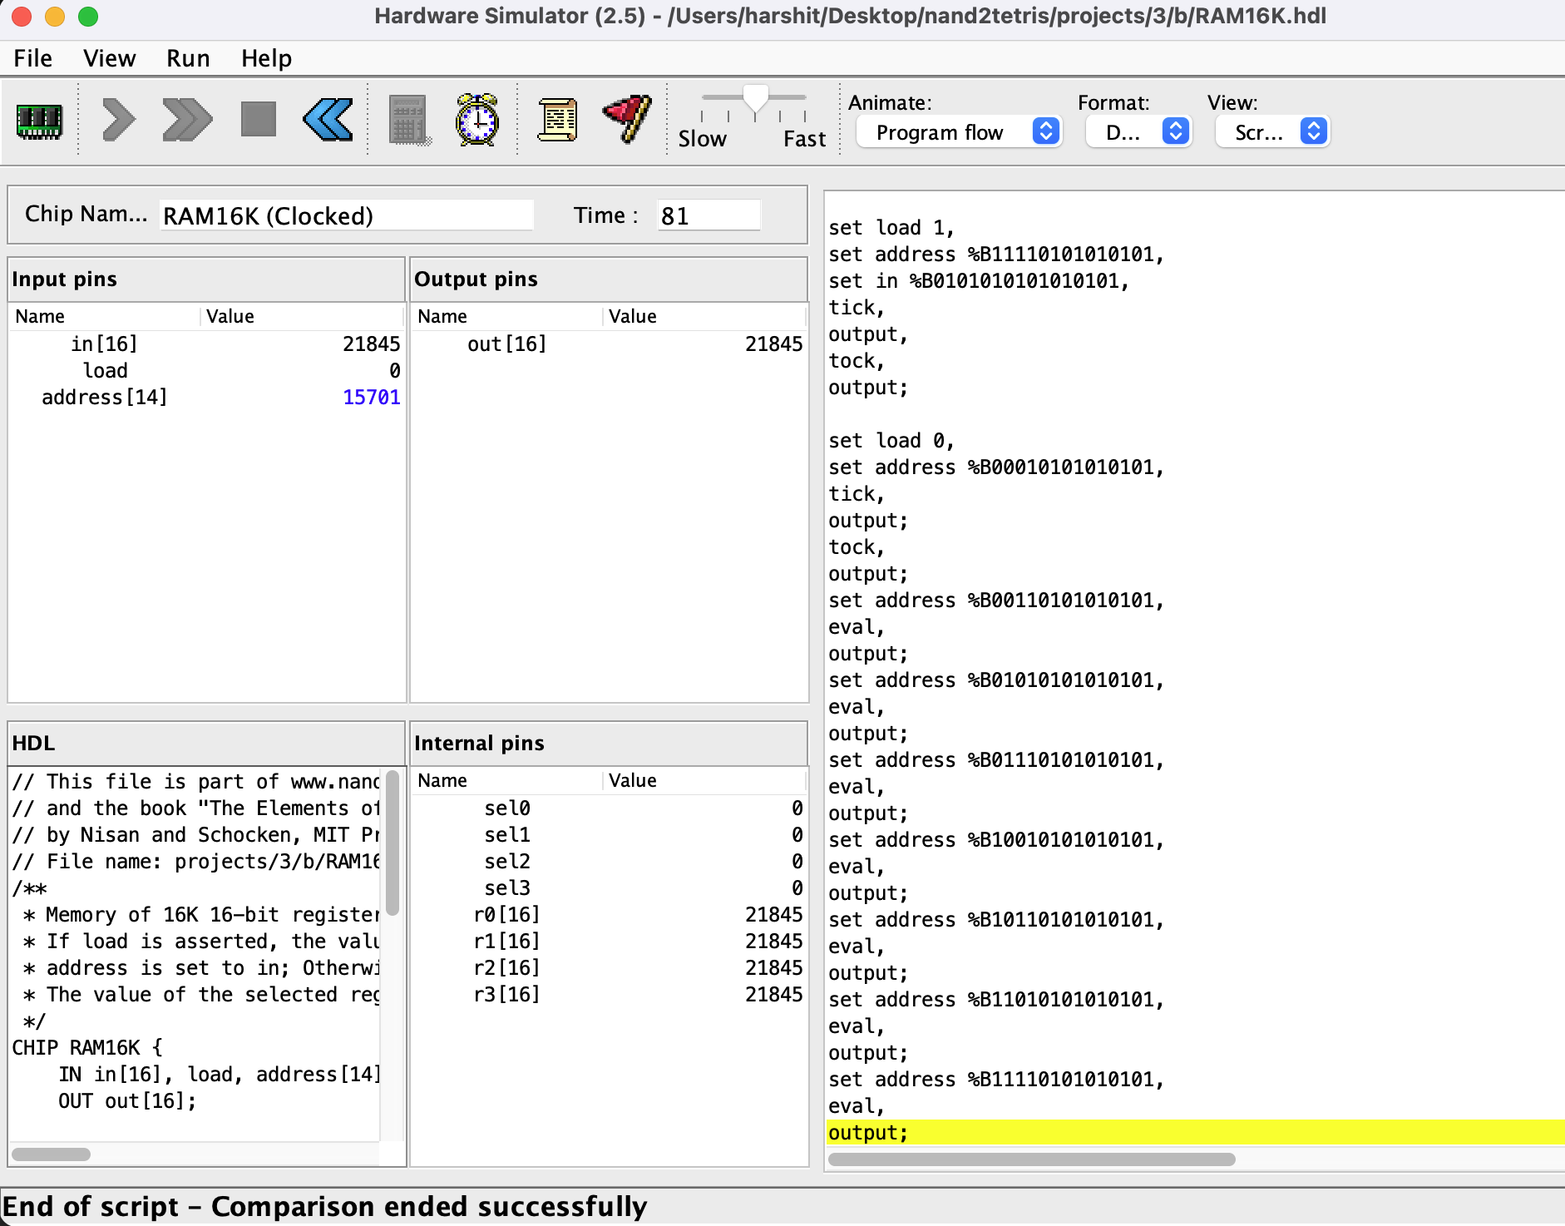

Project 4:
- Fill the screen black:
Code:
@color // declare color variable
M=0 // by default is white

(LOOP)

@SCREEN
D=A
@pixels
M=D // pixel address, goes from 16384 to 16384 + 8192 == 24576

@KBD // keyboard address
D=M
@BLACK
D;JGT // if(keyboard > 0) goto BLACK

@color
M=0 // set to white
@COLOR_SCREEN
0;JMP // jump to subroutine that colors the screen

(BLACK)
@color
M=-1 // set to black (2's complement 111111111...)

(COLOR_SCREEN)
@color
D=M
@pixels
A=M // VERY IMPORTANT! indirect address
M=D // color M[pixels] with @color

@pixels
M=M+1
D=M

@24576
D=D-A
@COLOR_SCREEN
D;JLT

@LOOP
0;JMP // infinite loop
Execution:
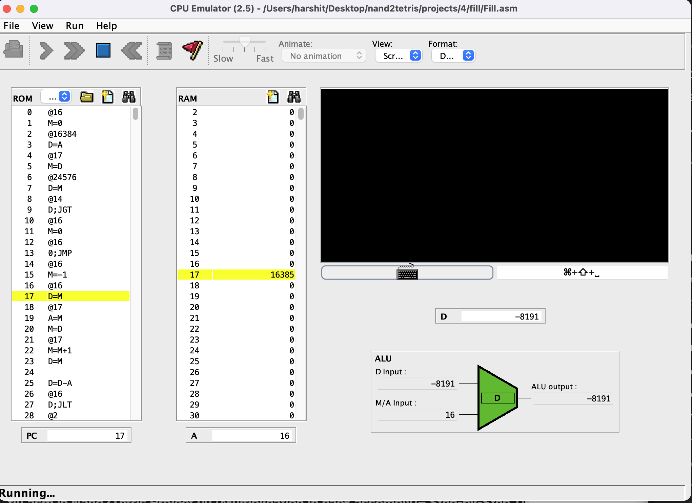

- Multiplication:
Code:
@R2
M=0
(LOOP)
@R1
D=M
@END
D;JEQ // if(R1==0) goto END

@R0
D=M // D = R0
@R2
M=M+D // R2 = R2+ R0

@R1
M=M-1 // R1--

@LOOP
0;JMP // goto LOOP

(END)

@END
0;JMP // infinite loop

